

SCSR2213 NETWORK COMMUNICATIONS
Task#4
Making The Connections - LAN And WAN

Group 4: Linux
SECTION: 5
Lecturer: Dr. Adnan Khalid

Name | Matric Number
Garrah Thabit Mohammed | A24CS4013
Mohammed Abdulrahim | A24CS4026
LEE TUNG ERN | A24CS0103
MOHAMMED ALSAKKAF | A23CS4026

Table Of Contents:
1. Introduction 3
- Brief explanation for the new task.
- Summary from the last task
2. Identifying the work areas on floor plan 4
3. The distribution and connection of devices 6
- Network Distribution Diagram.
- Room Level Network Distribution Diagram.
- ● Floor Diagram.
- Number of connections, patch cords and switch ports needed.

4. Identifying cable types and length 17
5. Meeting minutes 19



In the earlier tasks, we laid a strong foundation for the project. In Task 1, our team, "Linux," was formed, and we developed a comprehensive floor plan for the new two-story Faculty of Computing building, along with documenting our preliminary discussions in meeting minutes.
Task 2 involved a thorough analysis where we formulated over 10 focused questions to better understand the requirements and gather insights. Through detailed research and consultations, we assessed the current and future needs of the project, evaluated its feasibility, and made necessary revisions to our design to align with the expectations of stakeholders.
For Task 3, we selected the most suitable LAN devices that meet the objectives of the case study, ensuring that the building would be equipped with a robust and secure network infrastructure capable of meeting both current and future demands.
In this task, we will focus on designing the physical network infrastructure, including strategic placement of devices, cabling, and inter-floor connections to seamlessly integrate the new rooms into the overall network design. We will carefully plan for both horizontal and vertical cabling, choosing the right media (twisted pair, fiber optic, or wireless) based on the specific requirements. The ultimate goal is to create a reliable, high-performance network infrastructure for the new building.

- Working areas: First Floor Working Areas
The ground floor of the building, as shown in Figure 1, includes six distinct work areas.
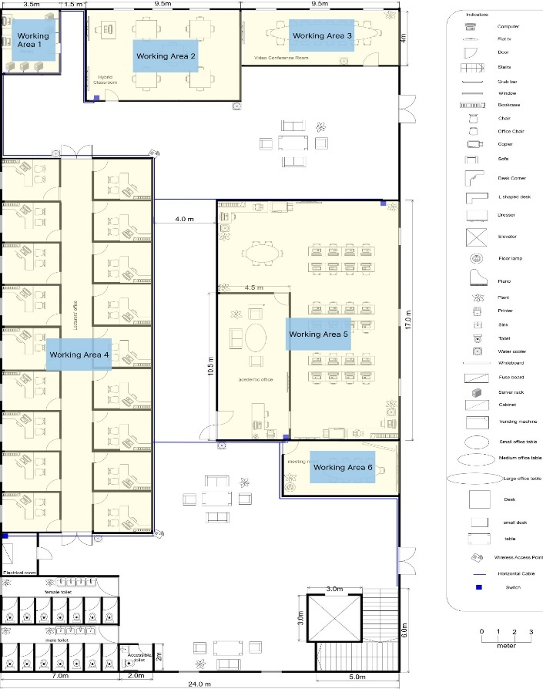
Work Area 1 is the Server Room, which is essential for the IT infrastructure. It houses five server racks responsible for managing data, applications, and network performance throughout the building. In addition, there are two workstations in the room, allowing IT staff to monitor and manage server operations effectively. These devices are critical to ensuring the smooth operation of the facility and supporting the overall network.
Work Area 2 is the Hybrid Classroom, which is equipped with two large TVs for displaying teaching materials and presentations, making it easier for instructors to share content with students. The classroom also contains a workstation for the instructor to facilitate lesson delivery and manage activities, ensuring a better learning experience.
Work Area 3 is the Video Conference Room, dedicated to virtual meetings and collaborations. This room features a large TV for video calls, presentations, and screen sharing, enabling participants to interact seamlessly.
Work Area 4 is the Lecturer’s Office, consisting of 18 individual rooms. Each room includes a workstation, providing lecturers with a private, quiet space to carry out administrative and academic work.
Figure 1: Work Areas in ground floor
Work Area 5 is the Academic Office, a space designed for both individual and collaborative work. It is equipped with 27 workstations to accommodate staff and students. Additionally, there are three TVs for presentations and information display. To support document management, two printers and two photocopiers are available.
Work Area 6 is the Meeting Room, which has a large TV for content display, facilitating meetings and enabling participants to share materials and collaborate effectively.
This setup ensures that each work area is optimally designed to meet the needs of different functions within the building.
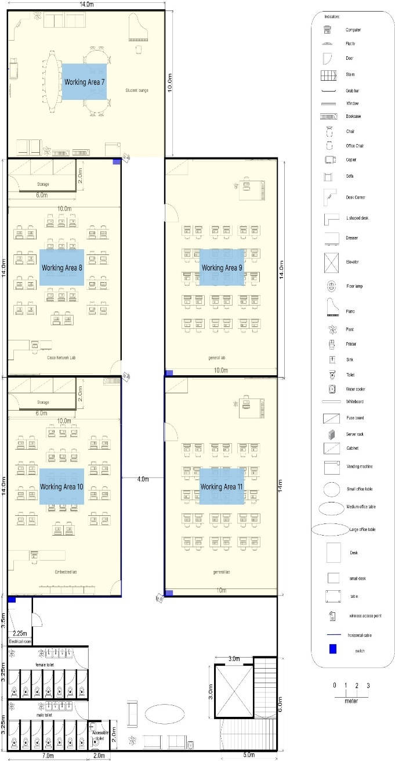
Figure 2 illustrates the work areas located on the first floor, which consists of five main workspaces.
Work Area 7 is the Student Lounge, designed as a space for students to relax, socialize, and collaborate. It features comfortable sofas, a large meeting table surrounded by chairs, and small tables, offering a flexible environment suitable for both individual and group activities. The lounge is also equipped with a TV for informational purposes and a photocopier to assist students with printing and copying tasks.
Work Area 8 is the Cisco Network Lab, a specialized facility for networking studies and hands-on applications. This lab is furnished with 31 workstations, including 30 for students and 1 for the lecturer. Additionally, there is a small storage room with three cabinets to organize tools, equipment, and other materials essential for networking activities, ensuring the lab remains organized and functional.
Work Areas 9 and 11 are the General Labs, each of which is equipped with 31 workstations: 30 for students and 1 for the lecturer. Both labs also feature a small storage area with three cabinets to store tools, equipment, and materials needed for various lab activities.

Figure 2: Work Areas in first floor
Work Area 10 is the Embedded Lab, dedicated to hardware programming and embedded systems projects. It includes 31 workstations, 30 for students and 1 for the lecturer. Like the other labs, the Embedded Lab also has a small storage space with three cabinets to store tools, components, and other necessary resources.
In summary, Figures 4.1.1 and 4.1.2 showcase a total of 11 work areas across the building, each carefully designed to support the diverse functions and activities within the facility.

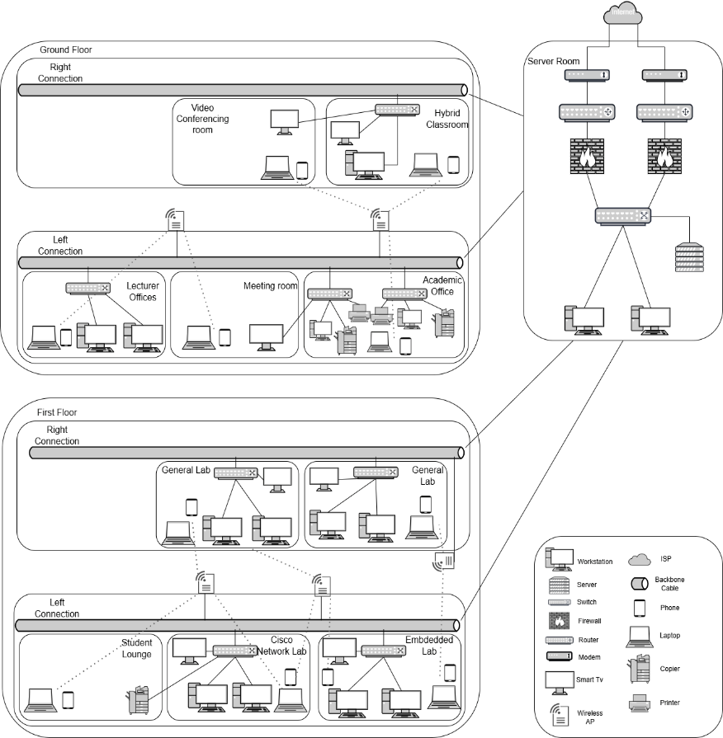
- The distribution and connection of devices
3.1 Network Distribution Diagram:
This diagram illustrates the network connections between the devices in the faculty building. It mainly highlights the wired and wireless links that connect the server room to the other rooms across the building.

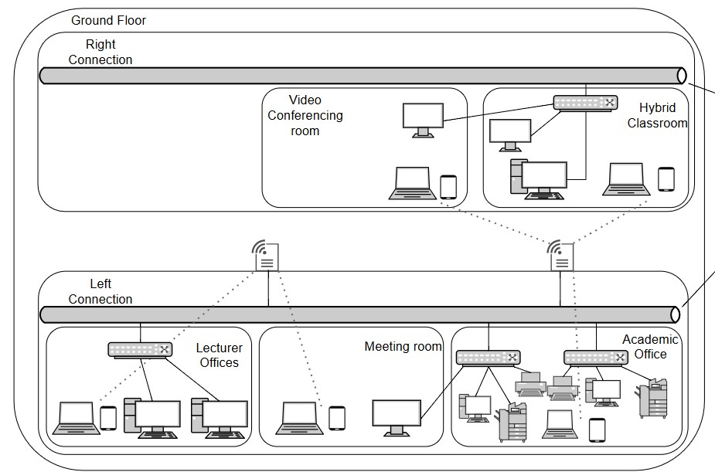

Figure 3.1.1 Network Distribution Diagram

Figure 3.1.1.1 Network Distribution Diagram - Ground Floor

Ground Floor:
As shown in Figure 3.1.1.1, there are two primary connections from the server room: one on the right and one on the left. The right connection includes a single switch located in the Hybrid Classroom, which then extends to the Video Conference Room. On the left, there are three switches: two in the Academic Office to support the heavy workload, and one in the Electrical Room that connects to the lecturers' offices. Additionally, the ground floor is equipped with two wireless access points to ensure wireless internet access throughout the area.

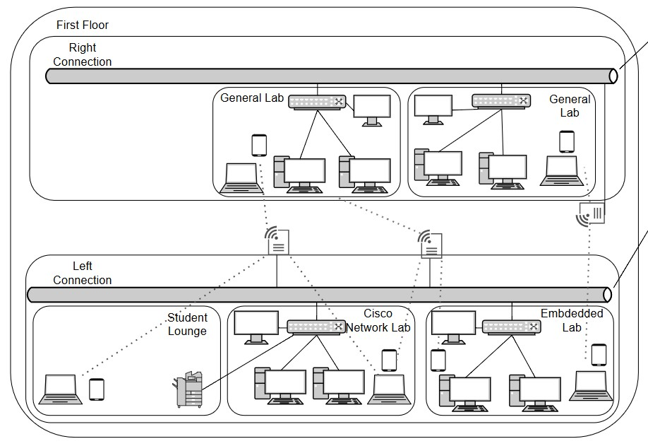
Figure 3.1.1.2 Network Distribution Diagram - First Floor

First Floor:
The first floor follows a similar setup to the ground floor, as shown in Figure 3.1.1.2, with both right and left connections. The right connection is linked to two switches, one in each General Lab, and includes a wireless access point. On the left side, there are also two switches: one in the Embedded Lab and one in the Cisco Network Lab. Additionally, the first floor is equipped with two wireless access points to ensure complete wireless coverage throughout the area.

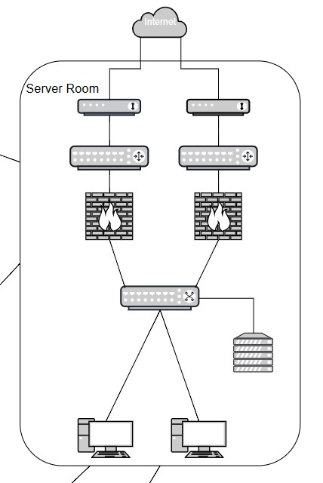
Figure 3.1.1.3 Network Distribution Diagram - Server Room

Server Room:
As seen in Figure 3.1.1.3, the server room utilizes a 2-tier network architecture, which allows it to manage the network traffic of the faculty building efficiently. This architecture is also more cost-effective compared to a 3-tier setup. The server room is equipped with an additional modem, router, and firewall to ensure redundancy, making the network more resilient. If one router fails, the other can continue managing the traffic until the problem is resolved. Furthermore, the server room contains two workstations that are directly connected to the core switch, allowing for better control over the network. The server itself is also linked to the core switch to ensure a stable and reliable connection.
- Room Level Network Distribution Diagram:

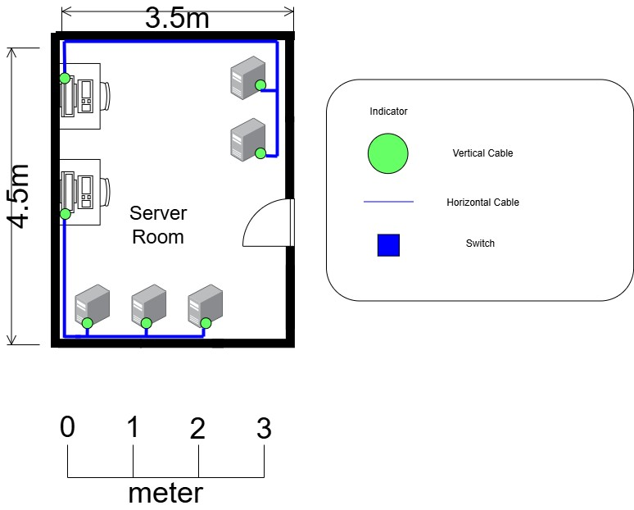

Figure 3.2.1 : Server room

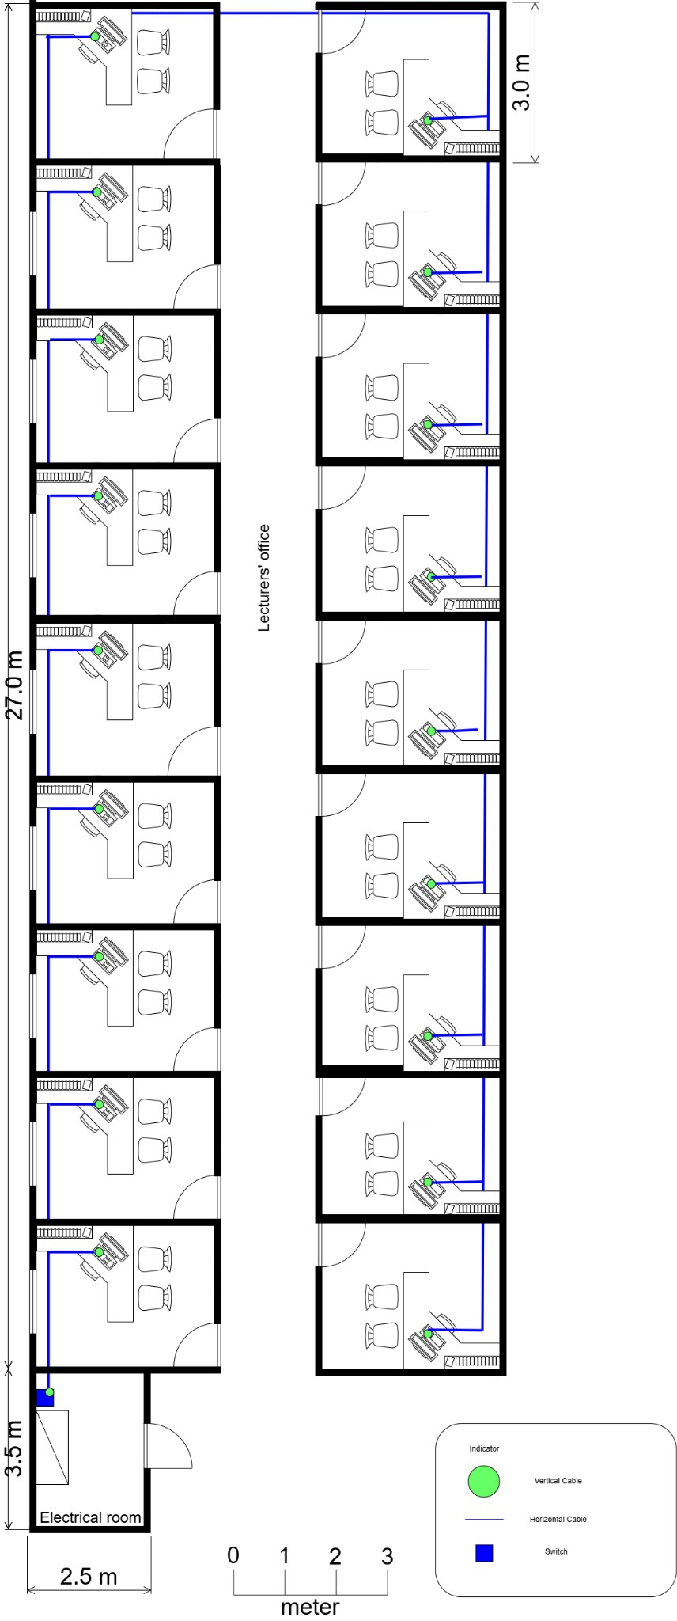
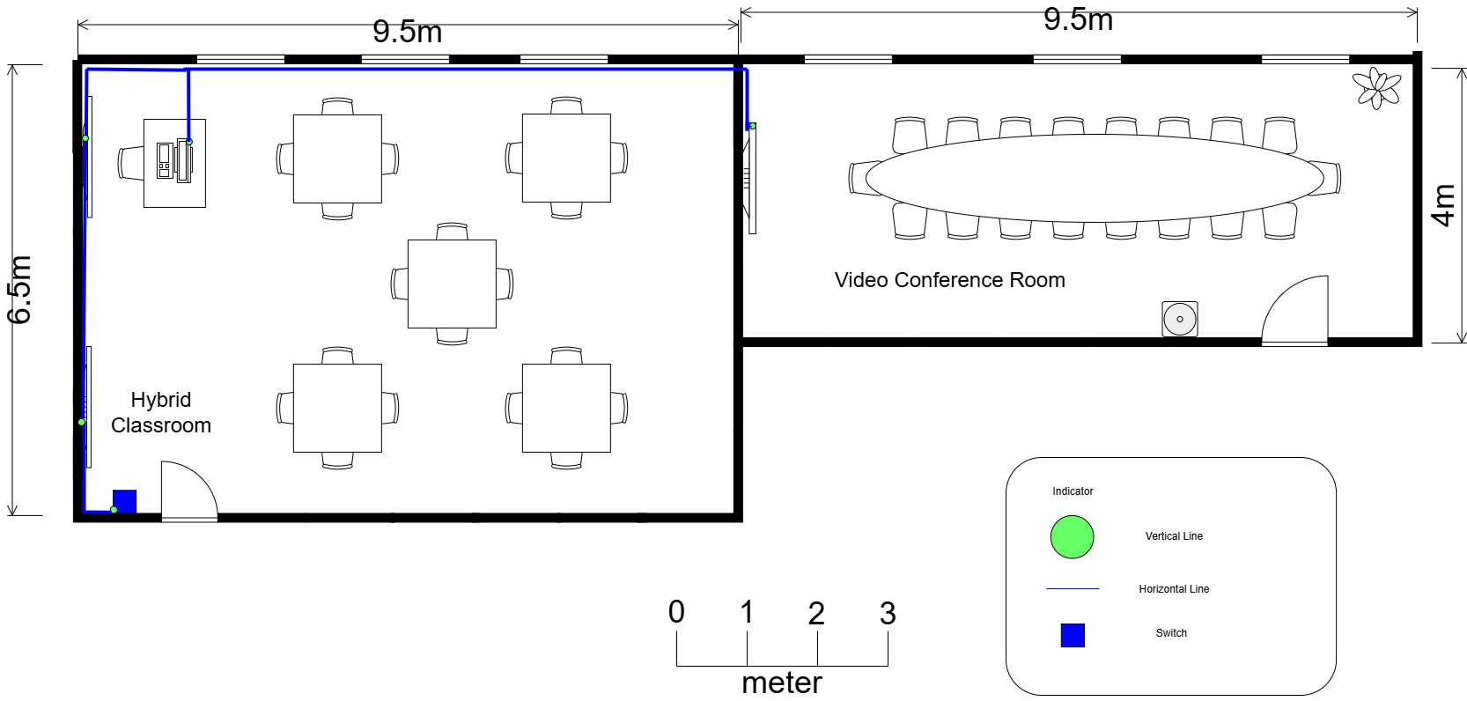

Figure 3.2.2 : Hybrid Classroom & video conference room

Figure 3.2.3 : Lecturer’s Office & Electrical Room

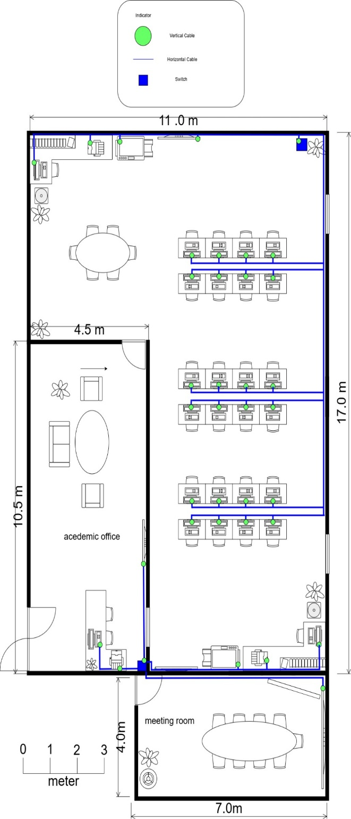

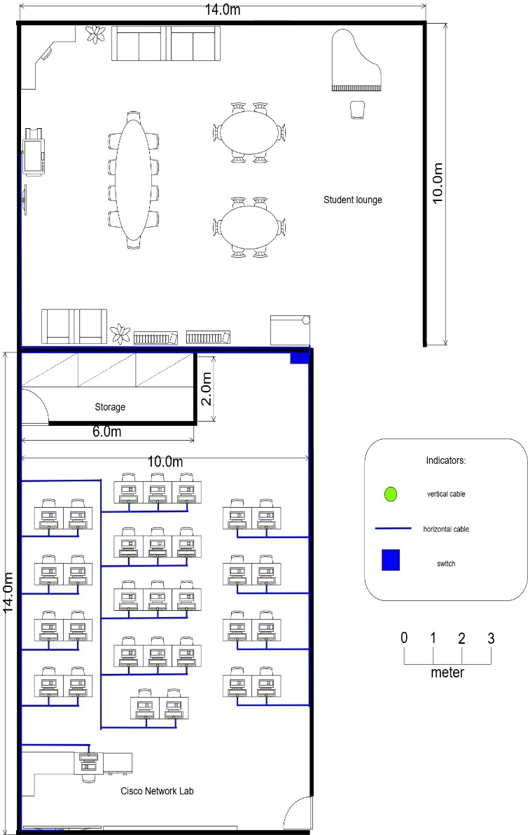

Figure 3.2.5: Student Lounge & Cisco Network Lab

Figure 3.2.5: Student Lounge & Cisco Network Lab

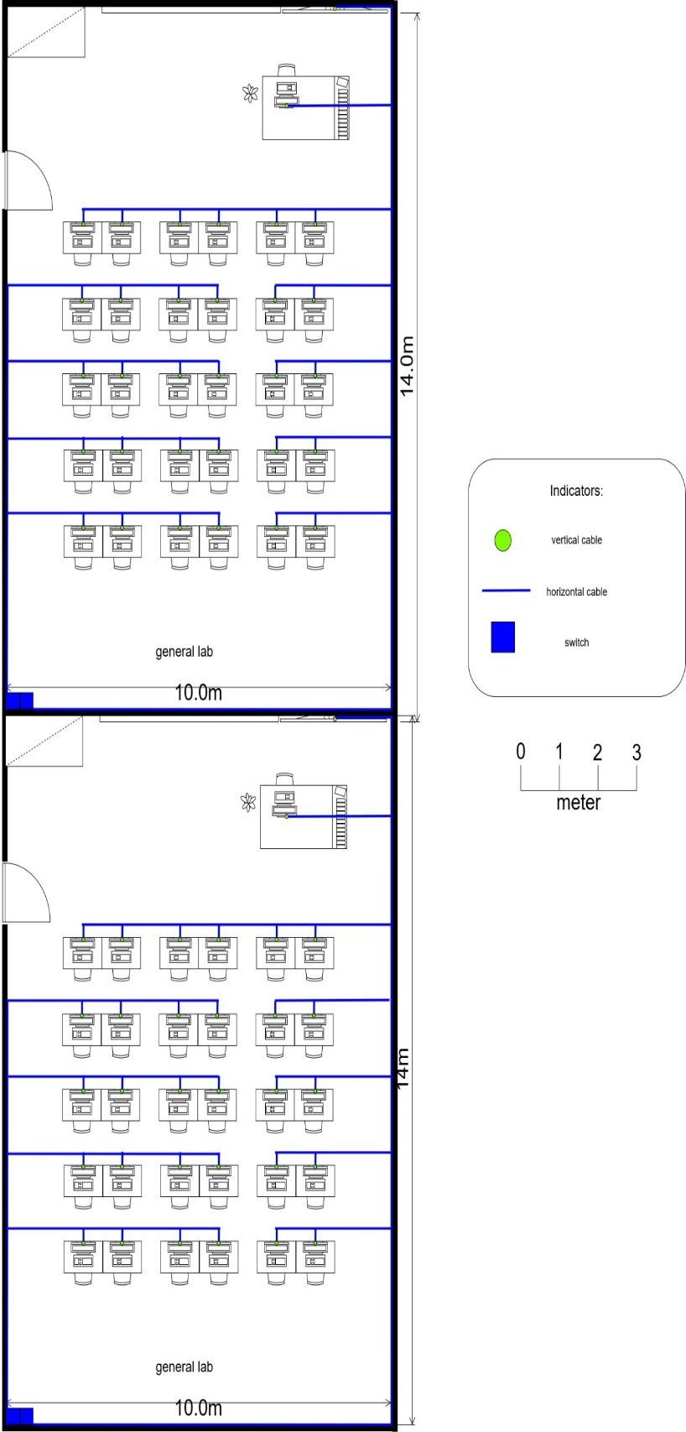

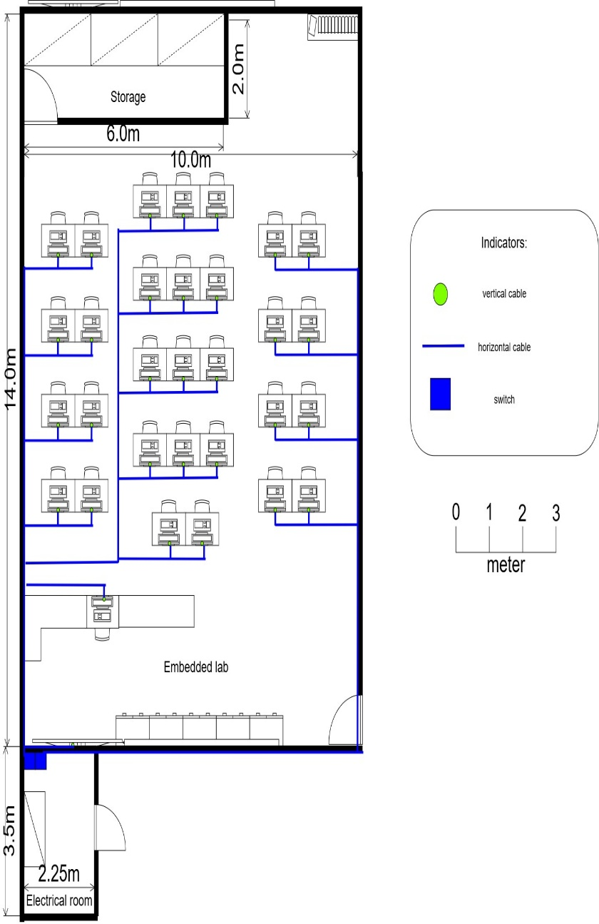

Figure 3.2.6 : Embedded Lab & Electrical room

Figure 3.2.7 : General Labs

Floor Diagram:

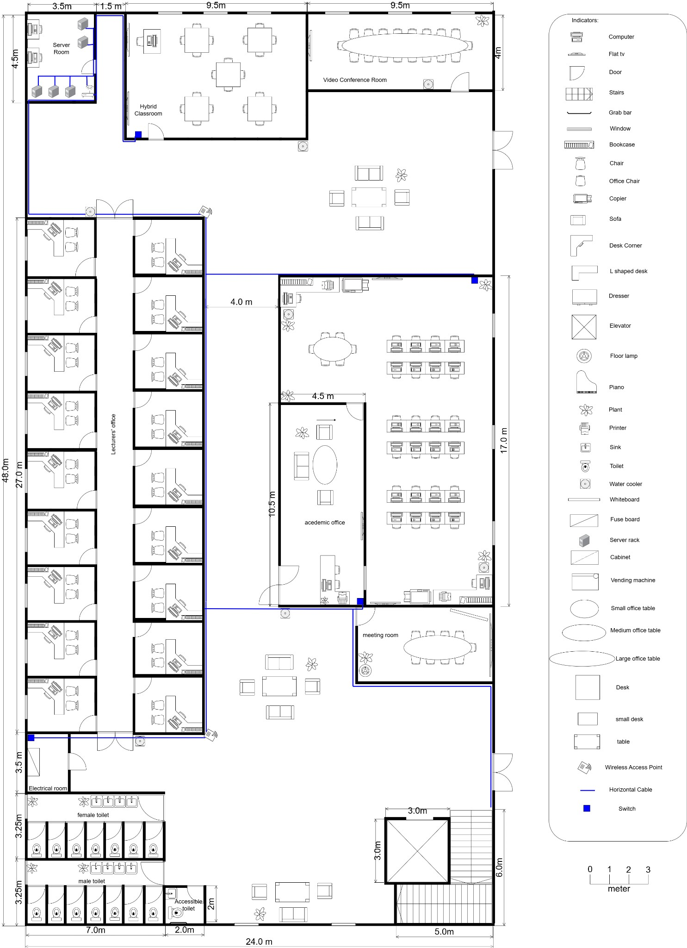
Figure 3.3.1 : Ground Floor
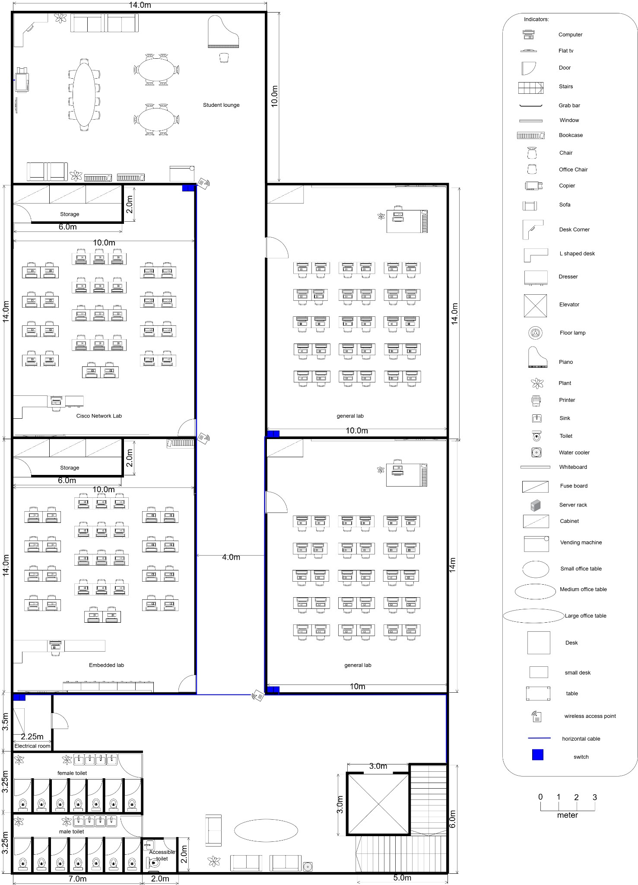

Figure 3.3.2 : First Floor
- Number of connections, patch cords and switch ports needed:
- Number of Switch Ports Needed:

Area | Number of Switch Ports Needed
Hybrid Classroom | 3
Video Conference Room | 1
Academic Office | 34
Meeting Room | 1
Lecturer’s Office | 18
Cisco Network Lab | 32
Embedded Lab | 32
General Lab 1 | 32
General Lab 2 | 32
Student Lounge | 2
Total | 187

- Number of Patch Cords Needed:

Area | Number of Patch Cords Needed
Hybrid Classroom | 3
Video Conference Room | 1
Academic Office | 34
Meeting Room | 1
Lecturer’s Office | 18
Cisco Network Lab | 32
Embedded Lab | 32
General Lab 1 | 32
General Lab 2 | 32
Student Lounge | 2
Total | 187

- Number of Connectors Needed:

Area | Number of Connectors Needed
Server Room | 14
Hybrid Classroom | 6
Video Conference Room | 2
Academic Office | 68
Meeting Room | 2
Lecturer’s Office | 36
Cisco Network Lab | 64
Embedded Lab | 64
General Lab 1 | 64
General Lab 2 | 64
Student Lounge | 4
Total | 374

- Identifying cable lengths And Prices:

- Lengths and Prices Table:

Area | Length (m) |  | Total Length (m) | Total Price of Cable Used (RM)
Area | Horizontal | Vertical | Total Length (m) | Total Price of Cable Used (RM)
Ground Floor
Room
Server Room | 9.7 | 2.8 | 12.5 | 83.38
Hybrid Classroom | 17.6 | 1.6 | 19.2 | 269.18
Video Conference Room | 1.4 | 0.2 | 1.6 | 22.43
Academic Office | 126.9 | 73.4 | 200.3 | 2808.21
Meeting Room | 7.4 | 0.6 | 8 | 112.16
Lecturer’s Office | 79.2 | 22.6 | 101.8 | 1427.24
Ground Floor Room Total |  |  | 343.4 | 4722.6
First Floor
Room
Cisco Network Lab | 84.9 | 25 | 109.9 | 1540.80
Embedded Lab | 81.2 | 25 | 106.2 | 1488.92
General Lab 1 | 92.25 | 25 | 117.25 | 1643.85
General Lab 2 | 92.25 | 25 | 117.25 | 1643.85
Student Lounge | 16 | 0.6 | 16.6 | 232.73
First Floor Room Total |  |  | 467.2 | 6550.15
Path |  |  | Length(m) | Price of cables used  (RM)
Total Path Length of Ground Floor |  |  | 110.1 | 1543.60
Total Path Length of First Floor |  |  | 69.6 | 975.79
Total (Ground Floor Rooms + First Floor Rooms + Path) |  |  |  | 13792.14 RM



In the previous section, we discussed how devices in the building are interconnected and how the network is distributed. To ensure that these connections are reliable, selecting the right type of cables is crucial. After discussing as a team, we decided to use a combination of CAT6 twisted-pair cables and fiber optic cables.
CAT6 twisted-pair cables will be used for the internal wiring within the building, such as in labs and lecture halls. These cables are ideal because they support high data transfer speeds of up to 10 Gbps. The thicker copper wires in CAT6 cables help reduce heat, making them capable of handling high power levels. This not only saves time during installation but also reduces costs. We opted for the Double Shielded Twisted Pair (STP) version of CAT6, as it is more durable and has a longer lifespan.
Fiber optic cables will be used to connect the routers in the server room and link the building to the Internet Service Provider (ISP). These cables transfer data using light, making them faster and more reliable. They can carry large amounts of data over long distances without any loss in signal quality. Fiber optic cables are essential for ensuring a stable and strong connection.
In conclusion, the building will require both CAT6 and fiber optic cables. This combination will provide fast, reliable connections within the building and ensure a strong link to the ISP.

Meeting Minutes 1
Date/Time | 7June 2025 10:00pm
Location | Online “google meet”
Agenda | 1. The task.  2. The suggested idea.  3. Task division.  4. Working on the project.
Meeting MC | Garrah Thabit Mohammed
Attendance
Name |  | Time | Reason For Absence
Garrah Thabit Mohammed |  | 10:00 pm | -
MOHAMMED ALSAKKAF |  | 10:00 pm | -
LEE TUNG ERN |  | 10:30 pm | -
Mohammed Abdulrahim |  | 10:10 pm
Minutes
No. | Items Discussed | Ideas/Suggestions and  Person Giving It | Person in Charge &  Date
1. | Identifying Work Area | Garrah initially identified the work areas and discussed them with the other team members. Once everyone agreed, he mentioned that he would finalize the labels after the meeting. | Garrah
2. | Connections | discussed the design of the network distribution diagram for the floor plan, and volunteered to create the diagram later and update the connection design. | Garrah
 |  | The group also discussed how to approach the floor plan connection design, deciding that two members would each handle the design for one floor. They would also calculate the length of cables and their costs. | The Team
 |  | volunteered to design the network connections for the ground floor, which includes six work areas. | LEE TUNG
 |  | Garrah volunteered to design the connection for the first floor, including 5 work areas. | Garrah
3. | Google docs | A collaborative document was created, and a table was set up to track the required cable lengths and types for the project. | Mohammed Abdulrahim
4. | Meeting ended | Meeting ended at11:30 pm. | -

